Graded Unit project

Silicon Croft Website

# Development

## Implementing the planned solution

### Identification of hardware and software platform

#### Server Selection

For our server hosting solution, we will compare a few options below:

* Webhosting UK are a UK-based host who provide both Linux and Windows hosting for a reasonable price, they also provide 24/7 technical support, daily offsite backups and 1-click installation of popular CMS’s such as WordPress, Drupal and Joomla (Webhosting UK **??**/05/2022).
* Wordpress.com provide free hosting of a WordPress site with the option to upgrade to a paid version when necessary. The free version is quite limited as it doesn’t allow plugins to be used, it puts adverts on your website which you do not receive revenue from and that cannot be removed, only provides up to 1GB of storage so would limit the amount of content that can be placed on the website, and is obviously limited to using WordPress as the CMS, however, as we have no budget our options are quite limited (WordPress.com **??**/05/2022).
* The University of the Highlands and Islands have allocated a virtual server for this project that is pre-installed with Red Hat Enterprise Linux, PHP, MariaDB and WordPress but I have been told I can change the CMS and configuration as I see fit.

From the options above we will be using the virtual server provided by the UHI as it has no hard limitations on the CMS we can use, plugins and data storage. It is also free which is a very limiting factor for the project as we have no budget and most other hosting options either have no free hosting available or the free hosting they do have is very limited and has other conditions attached such as requiring ads to be displayed on the created website.

#### Operating System Selection

##### Microsoft Windows Server 2022:

* Since Windows Server is owned and maintained by Microsoft and is not an open-source project you will get customer support with your purchase and so solving issues related to the operating system could be much easier and faster.
* A standard licence costs $1069 where if you chose an open-source solution it would be free (Microsoft 2021).
* Hardware Requirements (Microsoft 16/08/2021).
  + 1.4 GHz x64 processor (Microsoft recommends using a tool called Coreinfo to check that the CPU has all required capabilities: CMPXCHG16b, LAHF/SAHF, PrefetchW, etc)
  + 512 MB RAM (2GB for Desktop Experience installation)
  + 32GB backing storage (absolute minimum more is recommended)
  + Minimum 1 Gigabit ethernet adapter.

##### Red Hat Enterprise Linux:

* Red Hat Enterprise Linux is one of the most widely used Linux distributions, is the world’s leading enterprise Linux platform (Red Hat 2022) and has been around a long time which means it has a strong developer community producing regular updates and security fixes.
* While Red Hat Enterprise Linux is built on open-source software it is not free but does come with 24/7 technical support, access to Red Hat’s hardware, software and cloud partner ecosystem and, ten years of support from the release of each major version (Red Hat 2022). A standard licence costs $349.
* Hardware Requirements (Red Hat 2022)
  + 1 core or thread for each virtualized CPU and one for host.
  + 2 GB RAM (more recommended).
  + 6 GB Backing storage (minimum more is recommended).

##### OpenSUSE:

* OpenSUSE is a Linux distribution specifically aimed at “makers, sysadmins and developers” as well as normal desktop users.
* It’s completely free! OpenSUSE provide a “Premium IT Support” service for a Subscription fee similarly to Ubuntu.
* Hardware Requirements (OpenSUSE contributors 2021)
  + 2GHz dual core processor or better.
  + 2GB RAM (more recommended).
  + Over 40GB backing storage recommended.

I will be using Red Hat Enterprise Linux as the Operating System out of the options I have presented. Although there is a fee to use the operating system this is being provided free to me through the college for this project as they already have a server running that is using this operating system and are paying the necessary fees. This will also reduce the amount of time it will take to setup the server which is especially useful considering the reduced timescale I have to implement the project.

#### Web Server Selection

##### Microsoft IIS:

* IIS or Internet Information Services is Microsoft’s proprietary web server offering and has a market share of around 7% (Web Tech Survey 2022).
* IIS is closed source so has fewer people working on it and as such may be more vulnerable to attacks and slower to get patched.
* IIS is free but locks you into using a Microsoft operating system and does have some licencing costs depending on your usage (Microsoft IIS 2022).

##### Nginx

* Nginx was first released in 2004 and slowly gained popularity finally overtaking the number 1 spot by market share from Apache around 2019-2020. It is a well-established web server and so issues should be generally easy to fix.
* Nginx is open source and has a large number of contributors and full-time developers working on it which generally means it will be patched faster and be less vulnerable to attacks than a closed source alternative.
* Nginx comes in 2 versions either it is completely free and uses a BSD-type licence or there is a paid version that comes with additional enterprise features and support and a separate licence. The paid version requires you to contact sales for a price and most likely depends on usage (Nginx 2022).

##### Apache

* Apache was first released in 1995 but is still 2nd by market share, only being beaten recently by Nginx with a 2.4% difference (Web Tech Survey 2022). It has been around for a long time and is used all over the world so materials should be easy to find to diagnose and fix any issues encountered.
* Apache is open source and has many contributors and full-time developers working on it which generally means it will be patched faster and be less vulnerable to attacks than a closed source alternative.
* Apache is completely free and can be used under the very permissive Apache license.

I will be using Apache for this project because it is free and so meets our budget requirements, it is widely used and so faults and bugs should be easy to diagnose and fix, I am much more familiar with it than the other options available and it is pre-installed on the virtual server that I am going to be using for the project so will not require a lengthy installation.

#### Server-Side Scripting Language

Because all the Content Management Systems I am considering use PHP as their backend there are no other suitable options to choose from and so that is what I will be using, it is also the language I am most familiar with, so it makes sense in that way as well.

#### Database

As we require a database to allow easy addition of content to the website through a CMS and we need to use free solutions since there is no allocated budget for the project it makes sense to use a MySQL based RDBMS. I will be using MariaDB as it is one of the most popular open-source forks of MySQL, it is created by the original developers of MySQL, it guarantees to stay open source, and it contains some advanced features not found in other database servers (MariaDB 2021).

#### Content Management System

I have to use a content management system in conjunction with a database as discussed above in order to make the creation and publication of new content to the website by non-technical users as straightforward as possible. There are several content management systems available however some of them do not allow self-hosting and don’t export properly (Wix 2022, SquareSpace 05/05/2022) so are not appropriate for this use case such as Square Space and Wix. The 2 leading systems based on market share that allow self-hosting are WordPress and Joomla, however, there is another solution called Drupal that claims an 11% market share in the 10,000 most popular websites as of writing.

##### Drupal

* Drupal was initially released in 2001 and has slowly gained market share up until today where it has 11% within the 10,000 most popular websites however it doesn’t have as high a market share over the entire internet and so finding solutions to problems encountered could be more difficult than when using a more widely popular solution (BuiltWith 15/05/2022).
* Drupal is free and open source which means that more people are able to view and make contributions which can increase the security of the solution but as it is not as popular as the other options it does not have as many contributors actively working on it.
* Drupal can be extended with modules to add additional functionality and features to your website. There are over 40,000 modules available through the official directory which is similar to the number of official WordPress plugins, however, WordPress has significantly more plugins available through 3rd party developers (Drupal 2022).

##### Joomla

* Joomla was initially released in 2005 and has slowly gained market share up until today where it has 1.89% over the entire internet. While this is significantly higher than Drupal it is still very low compared to WordPress and so finding solutions to problems encountered could be more difficult (BuiltWith 31/10/2021).
* Joomla is free and open source which means that more people are able to view and make contributions which can increase the security of the solution but as it is not as popular as WordPress it does not have as many contributors actively working on it and, finding and patching security vulnerabilities.
* Joomla can be extended with extensions to add additional functionality and features to your website. There are, however, only around 6,000 extensions available through the official directory which is significantly less than the other options available (Joomla 2022).

##### WordPress

* WordPress was initially released in 2003 and it quickly became the most popular CMS on the internet today being used by approximately 41% of all websites on the internet, as such it should be relatively easy to find solutions to most problems encountered while using it (BuiltWith 31/10/2021).
* WordPress is free and open source which means that more people are able to view and make contributions which will increase the security of the solution compared to the others as it is the most popular and has the most contributors actively working on it.
* WordPress can be extended with plugins to add additional functionality and features to your website. There are almost 60,000 plugins available through the official directory which is slightly more than Drupal and it also has significantly more 3rd party websites hosting plugins (WordPress 2022).

Out of these I will be using WordPress due to its vastly greater usage over the internet. I have used WordPress in the past and so will be able to get the website up and running and create a manual on how to add content to the website much faster than I would be able to if I had to learn the ins and outs of a new CMS. Another advantage that comes with heavily used open-source software such as WordPress is that it often has a strong development team behind it and receives security fixes quickly (apache@GitHub 29/10/2021).

#### CMS Theme

As the website is for a business, needs to be responsive, needs to be easy to read and has a generally grey, white and green theme (based on the images provided by the client) a theme that could fit these needs had to be selected.

The theme I have chosen is called Shoreditch which is a functional-first responsive WordPress theme designed with business usage in mind. It has 2 simple page templates which is perfect for this project as the website is mostly interested in providing information to users and doesn’t require much in the way of complicated functionality. It uses a clear font that is easy to read and has a grey and white based theme which will work well with the example assets the client has provided (Shoreditch Theme 2022).

#### CMS Plugins

As the client has indicated in the initial meeting that they will be adding blog posts to the website in the future I suggested that they might wish to add people who are interested to a newsletter service that they can then use to notify those people when a new blog post is created. The client has agreed to this suggestion and so we will be using the Simple Newsletter Plugin by Noptin to fulfil this role (Simple Newsletter – Noptin 2022).

### Installation and configuration of server software

#### Operating System

As we are using a pre-configured server with an operating system pre-installed we do not need to install an operating system. We can however create a simple page on the pre-installed web server that displays information about the system and use this to confirm that we actually have the operating system we expect to have installed. First, we will create the webpage and upload it to the server using ftp.

Next we will navigate to <http://www.webcomputing.co.uk/project5/test.php> in a web browser and look for the relevant information in the returned webpage.

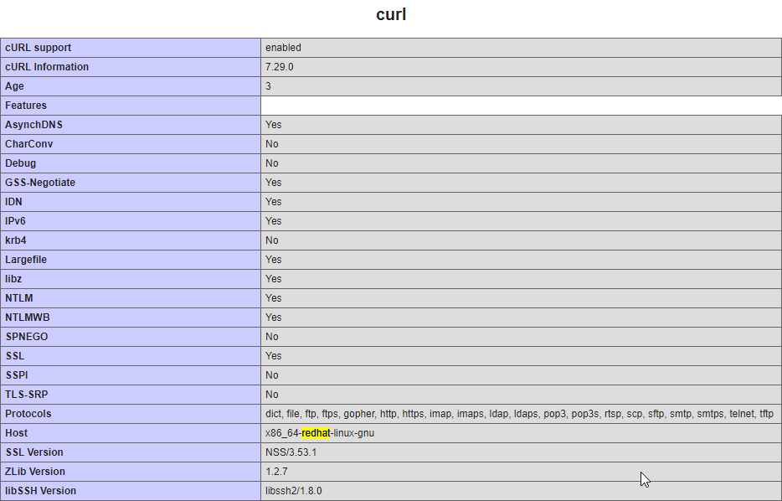

As you can see Red Hat Enterprise Linux is the operating system running on the webserver.

#### Web Server

Again, as we are using a pre-configured server with all the software we are intending to use already installed I am only able to show that Apache is indeed already installed with another extract from the same webpage showing multiple mentions of Apache being the server software.

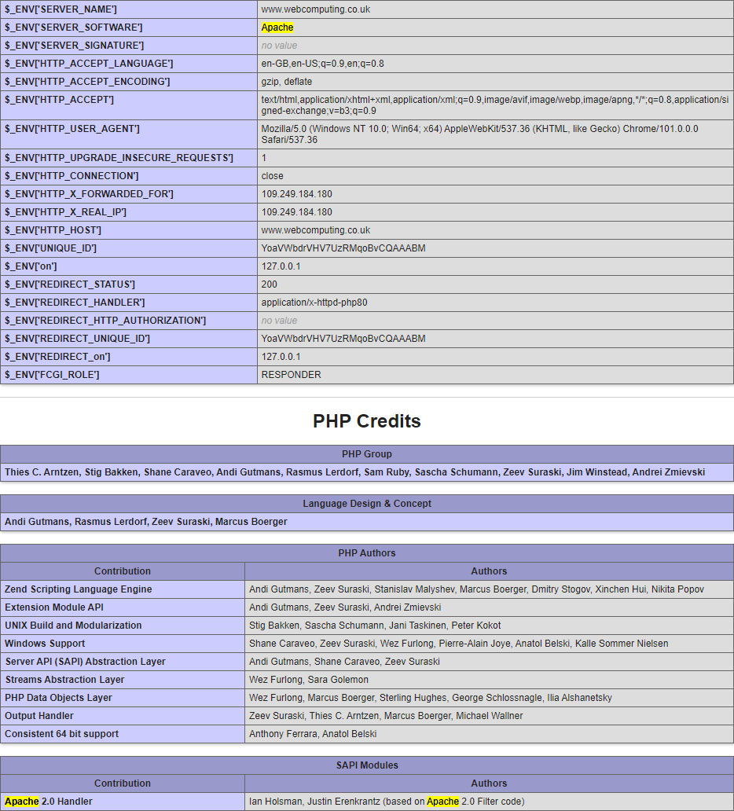

#### Database

Maria-DB has been pre-installed on the server and so we do not need to install it we can show that it is installed by either taking another excerpt from the webpage we have been using:

or we can create a connection to the database server and log in:

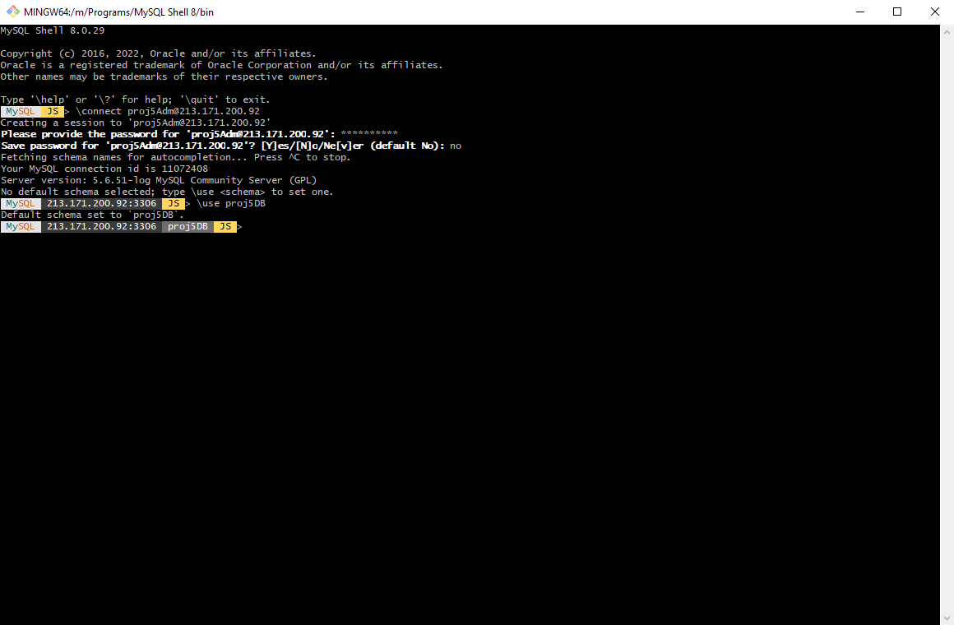

#### Server-Side Scripting Language

PHP 8 is pre-installed for us so does not need to be installed and we can show that it is installed by the mere fact that the webpage we created works but also by taking another excerpt from the webpage.

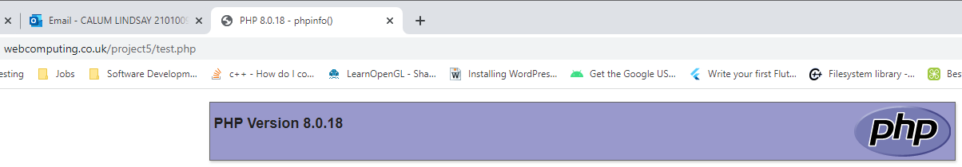

#### Content Management System

WordPress like all the other software we are using has been pre-installed for us and we can show this by using ftp to connect to the server and list all the files in the root of our webspace which will have all the typical files of a wordpress installation (wp-admin, wp-config.php, wp-settings.php, etc, etc).

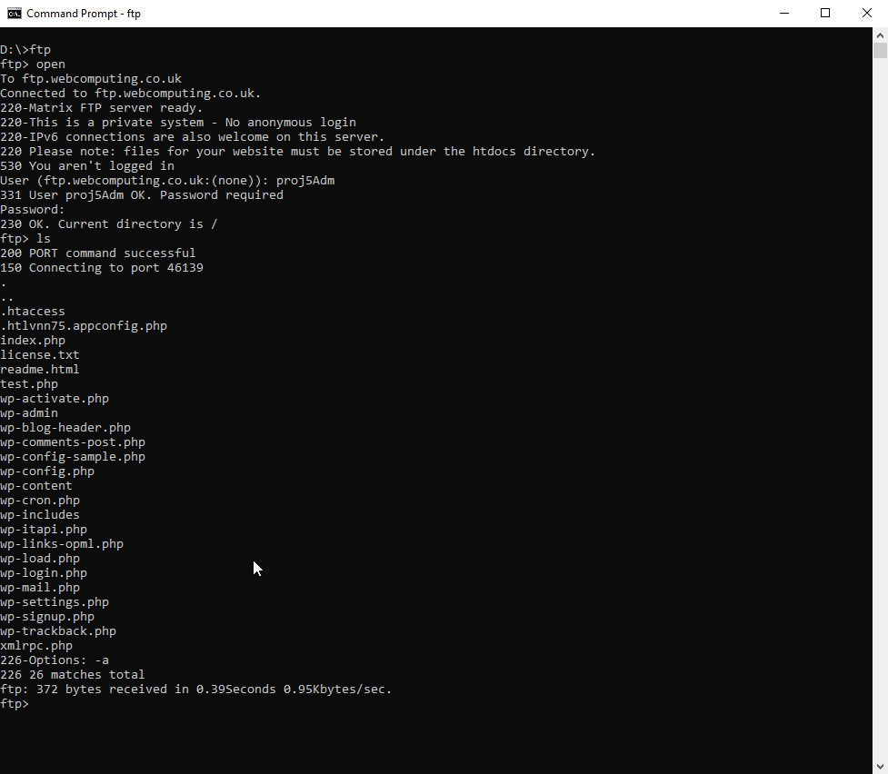

We can also show it is there by logging in at <http://www.webcomputing.co.uk/project5/wp-login.php>

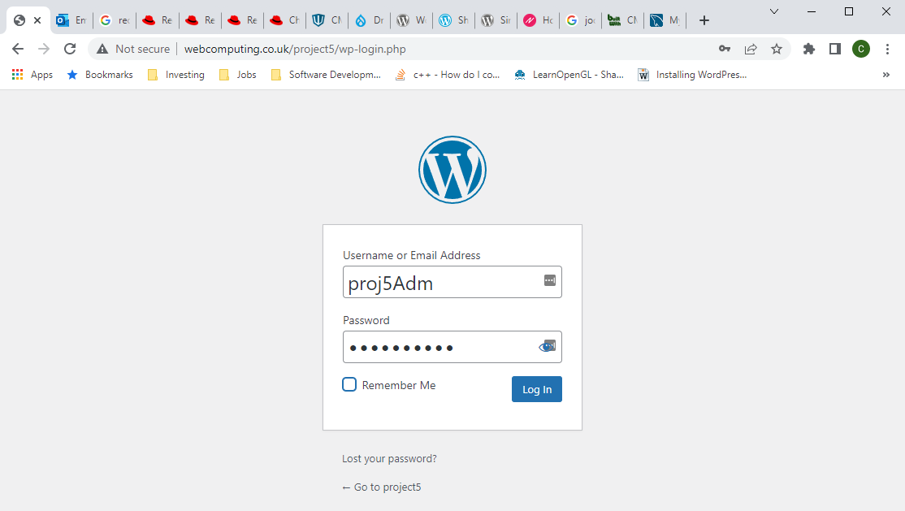

Once we have logged in we will get to the WordPress admin area.

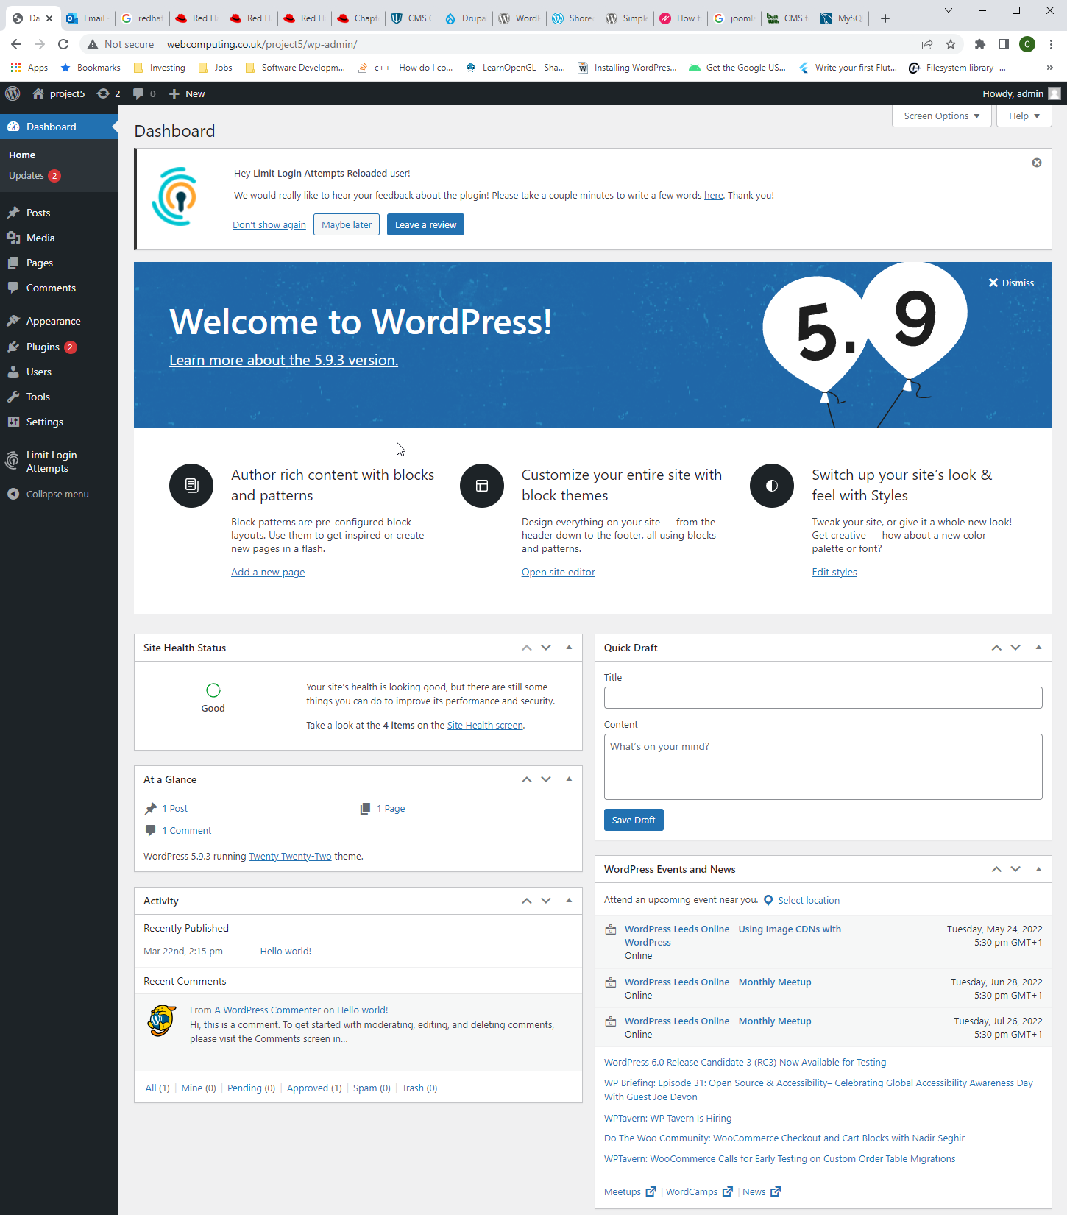

#### CMS Theme

To install the shoreditch theme from the wordpress dashboard we have to click on Appearance then Themes.

Then we click the add new button near the top of the page and then search for shoreditch using the search box at the top right of the page.

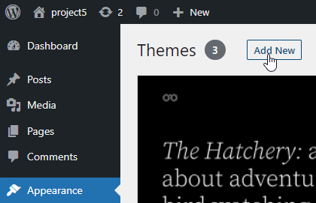

Finally, we will click install and once it has been installed, we can click activate and we are done, that is the theme installed and active.

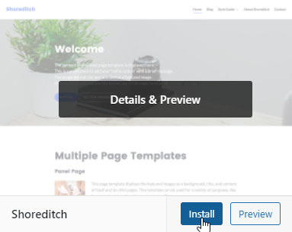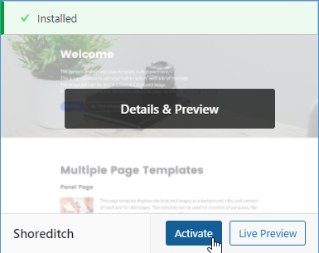

#### CMS Plugins

To install the

### Implementation of the prototype website

#### Planning (19/05/2022)

##### Pages

###### HomePage

###### Blog

###### Engagement Pipeline

###### About Us

#### Implementation

### Testing

#### Testing Plan

#### Testing Data

### Retrospective on the Management of the Project

I believe that I managed the project as well as I could considering that I was significantly forestalled during the planning stage by events in my personal life and so started the implementation stage 9 weeks late and had/have a much shorter period in order to finish it and the evaluation stage. There were no amendments required to the project plan as all deliverables and milestones were completed and delivered on the dates predicted and, all tasks and assignments were completed as quickly and accurately as possible due to the strict time limitations.

# Bibliography

Webhosting UK **(**2022) – Shared Linux Web Hosting With cPanel [online]. Available from <<https://www.webhosting.uk.com/cpanel-hosting>> [??/05/2022]

WordPress.com (2022) – WordPress Hosting | Managed WordPress Hosting [online]. Available from <<https://wordpress.com/hosting/>> [??/05/2022]

Microsoft (2021) Windows Server 2022 Licensing & Pricing [online]. Available from

<<https://www.microsoft.com/en-gb/windows-server/pricing>> [02/11/2021]

Microsoft (16/08/2021) Hardware requirements for Windows Server [online]. Available from

<<https://docs.microsoft.com/en-us/windows-server/get-started/hardware-requirements>> [02/11/021]

OpenSUSE contributors (2021) openSUSE Leap - Get openSUSE (Download Tab) [online]. Available from  
<[https://get.opensuse.org/leap](https://get.opensuse.org/leap/)/> [02/11/2021]

apache@GitHub (29/10/2021) httpd trunk commit list [online]. Available from  
<<https://github.com/apache/httpd/commits/trunk>> [02/11/2021]

BuiltWith (10/05/2022) CMS Usage Distribution on the Entire Internet [online]. Available from  
<<https://trends.builtwith.com/cms/traffic/Entire-Internet>> [13/05/2022]

BulitWith (15/05/2022) Open Source Distribution in the Top 10k Sites Available from <<https://trends.builtwith.com/shop/open-source/traffic/Top-10k>> [16/05/2022]

<https://www.drupal.org/project/project_module>

<https://en-gb.wordpress.org/plugins/>

<https://www.joomla.org/>

Red Hat Customer Portal (2022) – Chapter 1. System Requirements [online]. Available from <<https://access.redhat.com/documentation/en-us/red_hat_enterprise_linux/7/html/virtualization_deployment_and_administration_guide/chap-requirements>> [??/05/2022]

<<https://www.redhat.com/en/technologies/linux-platforms/enterprise-linux>> [??/05/2022]

<https://webtechsurvey.com/technology/apache>

<https://www.nginx.com/pricing/>

<https://www.iis.net/>

<https://wordpress.com/theme/shoreditch>

(Simple Newsletter – Noptin 2022) Simple Newsletter Plugin – Noptin [online]. Available from <<https://en-gb.wordpress.org/plugins/newsletter-optin-box/>> [??/05/2022]